Association Executives Summit (AES)
19-20 November 2013
MR4, Philippine International Convention Center (PICC)

Proposed Program
- as of 11 November 2013 -

DATE | ACTIVITY
19 November 2013, Tuesday

8:00 – 9:00 a.m. | Registration
9:00 - 9:15 | AES Opening Ceremony  National anthem and invocation  Venue: Meeting Room 4  Welcome Remarks  Speaker: Atty. Renato B. Padilla (confirmed)  General Manager, Philippine International Convention Center
9:15 - 9:45 | Opening Keynote  Keynote Speaker: Hon. Ramon Jimenez, Jr. (TBC)  Tourism Secretary  Ramon R. Jimenez, Jr. is the current Secretary of the Department of Tourism.  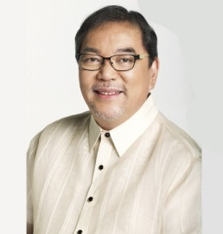  He is a writer, creative director and mentor, and considered to be one of the pillars of Philippine advertising. He has worked as a Journalism and Marketing communications instructor in some of the country’s most renowned universities, such as the University of the Philippines and the University of Asia & the Pacific.  Since the DOT Campaign “It’s More Fun in the Philippines ” was launched, it has been drawing attention around the world and generating more awareness for the Philippines, as a fun tourist destination.
9:45 - 10:00 | Coffee Break  Venue: Meeting Room 5
10:00 - 12:00 | Track 1  Venue: Meeting Room 2 &3  Topic : Characteristics of a Remarkable Association – Part 1  Sub-topics:  - Building high performance staff and organizations  - Characteristics of strong leaders  - Effective association governance  - What remarkable associations do that others do not  - Membership recruitment and retention strategies  - Financial sustainability  - Developing sponsorships/fundraising strategies  Speakers : Ms Susan Sarfati  CEO, High Performance Strategies  Susan Sarfati spent 25 years as President and CEO of the Greater Washington Society of Association Executives, the founding President and CEO of The Center for Association Leadership and Executive Vice President of the American Society of Association Executives (ASAE). In 2008 she formed her company which focuses on growing organizations and leaders that stand tall.  She has created extensive relationships in the association and business community. Her expertise focuses on leadership, management, sustainability, women's issues, creating extraordinary customer experiences and cultures, high performance organizational strategies, sales and marketing, innovation, and creating successful meetings and learning communities. She is well known in the meetings industry and has designed and delivered meetings for up to 6,000 attendees domestically and internationally.  Ms Liz Jackson  President, Jackson Consulting, Inc.  Liz Jackson has extensive experience in the arena of association management as vice president of Association Management Group and as the founder of its Meetings Management Group division. She spent over twenty years as a convention sales executive for the former Eastern Airlines and president of Associated Luxury Hotels (ALHI).  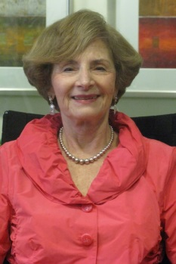  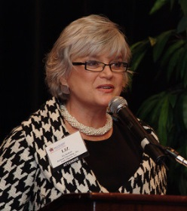  She has been contracted by the Center for International Private Enterprise (CIPE) for many assignments working with women’s business Associations in developing countries around the globe, creating mentoring projects with US association executives partnering with association managers from other countries and she has organized six-week internships at DC-based associations for young association managers from developing countries.
12:00 - 1:30 | Lunch  Venue: Meeting Room 5
1:30 - 3:00 | Track 1 (continued)  Venue : Meeting Room 2 &3  Topic : Characteristics of a Remarkable Association – Part 2  Speakers: Ms Liz Jackson  President, Jackson Consulting, Inc.  Ms. Susan Sarfati  CEO, High Performance Strategies  Sub-topics:  - Building high performance staff and organizations  - Characteristics of strong leaders  - Effective association governance  - What remarkable associations do that others do not  - Membership recruitment and retention  - Financial sustainability  - Developing sponsorships/fundraising strategies
3:00 - 3:20 | Coffee Break
3:20 – 4:50 | Track 2  Venue : Meeting Room 2 &3  Topic : Association Meetings: Bidding to Win  Sub-topics:  - Success strategies and best practices for winning the bid  - Benefits of hosting international meetings  - Support from the government and other organizations  - Strategies for excellent congress management  Speaker : Ms Monette Hamlin  President, Philippine Association of Congress/Exhibition Suppliers  and Organizers (PACEOS)  Monette Iturralde-Hamlin is president and founder of TeamAsia. Monette leveraged a distinguished career in international publishing to conceptualize and create Asia's first agency dedicated exclusively to corporate identity development and non-traditional marketing communications. She developed the business and creative processes that made TeamAsia not just a pioneer in Asia, but an arbiter of industry performance standards.  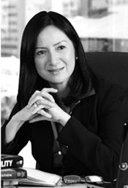  Monette is in high demand for her professional organizational skills, management expertise, and attention to detail. She is also a popular seminar facilitator, and delivers workshops on Presentation Skills, Business Writing, and Dealing with Difficult People. Monette's professional associations include the Personnel Management Association of the Philippines and the Philippine Association of Conference and Exhibit Organizers and Suppliers.
4:50 – 5:00 | Plans for Town Hall Meeting  Ms. Susan Sarfati and Ms. Liz Jackson
5:00- 6:15 | Light cocktails and networking  Venue: Meeting Room 5
-End of Day 1-

20 November 2013, Wednesday

9:00 - 9:30 | Recap of Day 1 and introduction of activities for the day  Ms. Liz Jackson and Ms. Susan Sarfati with Octavio B. Peralta, Secretary General , Association of Development Financing Institutions in Asia and the Pacific  Venue: Meeting Room 2 & 3  Town Hall Meeting – Creating an exceptional Philippine Council for the Advancement of Association Executives (PCAAE) and Launch!!  Speakers: Mr Octavio B. Peralta  Secretary General, ADFIAP  Ms Liz Jackson  President, Jackson Consulting, Inc.  Ms. Susan Sarfati  CEO, High Performance Strategies
9:30 – 10:30 | Town Hall Meeting  Venue: Meeting Room 2&3  Topics:  - Characteristics of a society of association executives that will exceed expectations.  - What will make the Philippine Council for the Advancement of Association Executives (PCAAE) so compelling that people will join and support it?  - Discussion of benefits of the PCAAE for the individual, organization and the Philippines Plans for launch of the PCAAE
10:30- 10:45 | Coffee break  Venue: Meeting Room 5
10:45- 11:15 | Continued Town Hall and Summary
11:15 - 12:00 | Closing Ceremony
12:00 | Lunch and celebration of the launch of the PCAAE
-End of Day 2-

